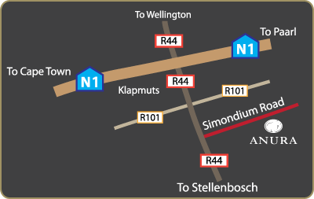
- Take the N1 in the direction of Paarl / Worcester
- Continue until you reach the exit for the R44 (Klapmuts)
- Turn right in the direction of Klapmuts and Stellenbosch
- Continue to the Simondium road and turn left
- After +-500m you will find the ANURA sign, turn right
- Follow the Anura signs to the Restaurant

